
INDUSTRY REPORT
Management Consultants in Norway
Sep 2025

About

IBISWorld
IBISWorld specializes in industry research with coverage on thousands of global industries. Our comprehensive data and in-depth analysis help businesses of all types gain quick and actionable insights on industries around the world. Busy professionals can spend less time researching and preparing for meetings, and more time focused on making strategic business decisions.

Table Of Contents | Factsheet

1. About 4
Codes 4
Definition 4
Related Terms 4
What's Included 4
Companies 4
Related Industries 5
2. At a Glance 6
Highlights 6
Country Benchmarking 7
Products and Services 8
Major Players 8
Key External Drivers 8
Industry Structure 8
3. Performance 10
Performance Snapshot 10
4. Products and Markets 15
Products and Services 15
Major Markets 15
5. Competitive Forces 17
Highlights 17
Buyer & Supplier Power 18
6. Companies 19
7. External Environment 20
Highlights 20
External Drivers 20
8. Financial Benchmarks 21
Highlights 21
Cost Structure 21
Key Ratios 22
9. Country Benchmarks 24
Structural Comparison 24
10. Key Statistics 26
Industry Data 26

1. About
https://my.ibisworld.com/no/en/industry/NO-M702/about

Codes
ISIC Rev. 4 | 702

Definition
Management consultants provide advice, guidance and operational assistance to businesses and other organisations on management issues. Principal areas of consultation include corporate strategic and organisational planning, marketing, human resources and operational management.

Related Terms

BIG FOUR
The nickname used to refer to the four largest professional services networks in the world: PricewaterhouseCoopers, Deloitte, KPMG and Ernst & Young.

RESTRUCTURING
Modifications to a business that can provide improvements to cash flow, profit and the corporate balance sheet.

CORPORATE STRATEGY
The formulation and implementation of the major initiatives taken by a company's top management on behalf of the owners.

What's Included
- IT strategy
- Corporate strategy
- Process and operations management
- Programme or project management
- Risk management
- Human capital
- Economic and regulatory consulting
- Business transformation consulting
- Customer and marketing strategy
- Environmental consulting

Companies
- Accenture plc
- McKinsey & Company Inc
- PricewaterhouseCoopers International Ltd
- Ernst & Young Global Ltd
- Boston Consulting Group Inc
- KPMG International Ltd
- Bain & Company Inc

Related Industries

Industries in the Same Sector
- Competitors:
  - Computer Consultants in Norway
  - Employment Placement Agencies in Norway
- Complementors:
  - Legal Activities in Norway
  - Accounting & Auditing in Norway

International Industries
- Management Consulting in the US
- Management Consulting in Canada
- Management Consulting in Australia
- Management Consultants in the UK
- Management Consultants in Germany
- Management Consultants in Ireland
- Management Consulting in China
- Management Consulting in Mexico
- Global Management Consultants

2. At a Glance
https://my.ibisworld.com/no/en/industry/NO-M702/at-a-glance

Highlights
Revenue  €3.5bn  ’20-’25 ↑ 0.9 %  ’25-’30 ↑ 2.0 % | Employees  16,785  ’20-’25 ↑ 6.8 %  ’25-’30 ↑ 1.0 % | Businesses  14,901  ’20-’25 ↑ 3.4 %  ’25-’30 ↑ 1.8 %
Profit  €857.3m  ’20-’25 ↑ 0.0 % | Profit Margin  24.3%  ’20-’25 ↓ 0.0 pp | Wages  €1.1bn  ’20-’25 ↓ 1.0 %  ’25-’30 ↑ 0.3 %

Country Benchmarking
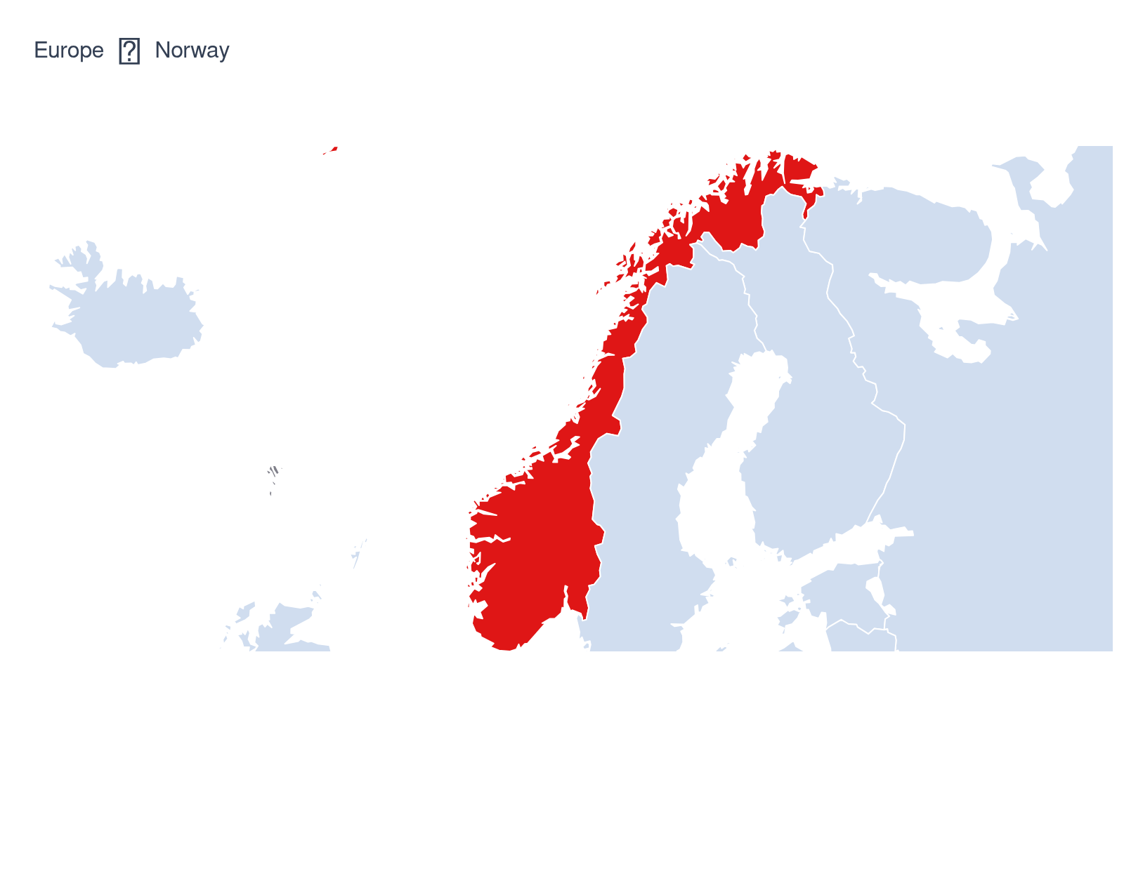
Industry Data Norway
Industry Data Norway
Revenue  #22  In Europe | Business  #21  In Europe | Employees  #23  In Europe
Wages
#16
In Europe

Products and Services
- IT strategy
- Corporate strategy
- Process and operations management
- Programme or project management
- Risk management
- Human capital
- Other services

Major Players
- Accenture plc
- McKinsey & Company Inc
- Other Companies

Key External Drivers
Key External Drivers | Impact
Business sentiment | Positive
Number of enterprises | Positive
Total public expenditure | Positive
Degree of digitalisation | Positive

Industry Structure
Characteristic | Level | Trend
Concentration | Moderate
Barriers To Entry | Low | Decreasing
Regulation and Policy | High | Decreasing
Life Cycle | Mature
Revenue Volatility | Low
Assistance | Moderate | Increasing
Competition | Moderate | Steady
Innovation | High

3. Performance
https://my.ibisworld.com/no/en/industry/NO-M702/performance

Performance Snapshot

Revenue:
Revenue  €3.5bn  ’20-’25 ↑ 0.9 %  ’25-’30 ↑ 2.0 % | 2025 Revenue Growth  ↑ 2.2 % | Revenue Volatility  Low
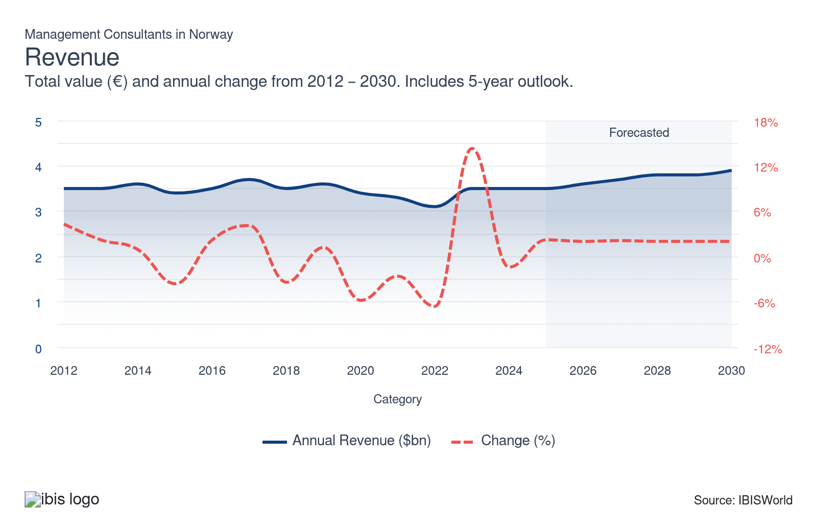

How does Norway's performance compare to Europe?
- The industry in Norway is forecast to generate revenue of €3.5bn in 2025, up 2.2% on the year.
- This equals a 0.7% to total European revenue of €487.4bn, representing the 22nd largest share.
- By €1.2bn, Norway underperforms the European median revenue of €4.7bn.
- At a difference of €1.4bn, Czechia is Norway's closest rival, where the former's revenue of €2.2bn underperforms the latter.
- Since 2011, and implying a Low level of volatility, Norway has had an average annual revenue change of 2.2%, most comparable to Poland (2%) and contrasting most to Turkey (17%).

Employees:
Employees  16,785  ’20-’25 ↑ 6.8 %  ’25-’30 ↑ 1.0 % | Employees per Business  1  ’20-’25 ↑ 3.4 %  ’25-’30 ↑ 0.7 % | Revenue per Employee  €210k  ’20-’25 ↓ 5.5 %  ’25-’30 ↓ 1.0 %
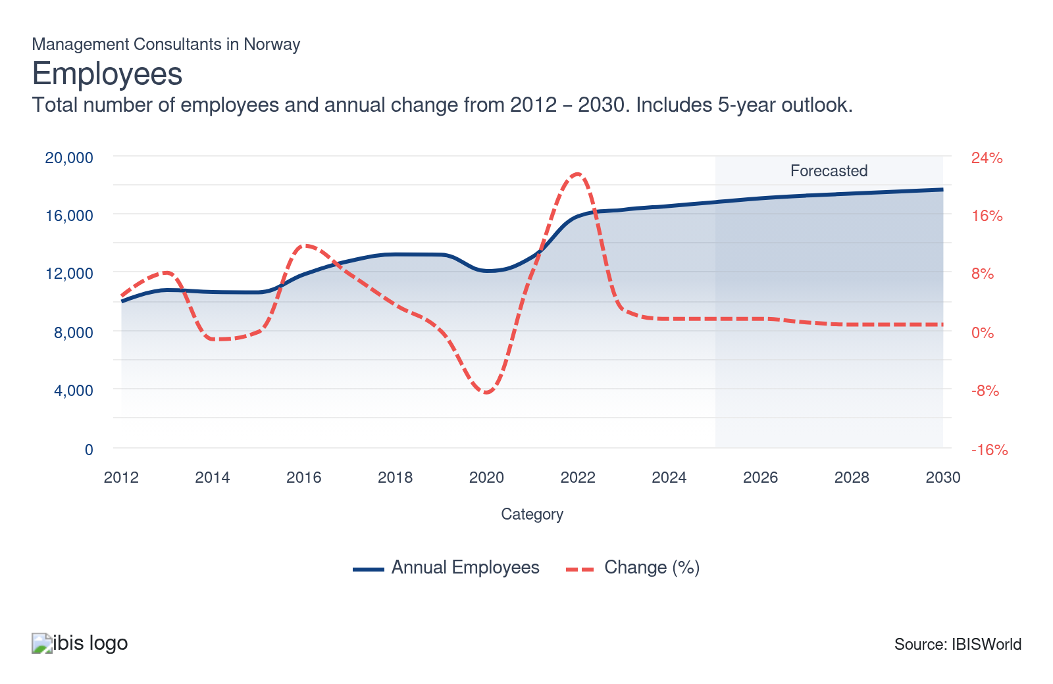

How does Norway's performance compare to Europe?
- The industry in Norway is forecast to have 16,785 employees in 2025, up 1.6% on the year.
- This equals 0.7% of the 3m people employed across European, making Norway the 23rd largest employer.
- By a difference of 7,899 people, Norway employes less people than the European median of 3m.
- The size of the industry in Norway with regards to the number of people employed, is closed aligned with Czechia, where 12,153 people are employed - a difference of 4,632 people.

Businesses:
Businesses  14,901  ’20-’25 ↑ 3.4 %  ’25-’30 ↑ 1.8 % | Employees per Business  1  ’20-’25 ↑ 3.4 %  ’25-’30 ↑ 0.7 % | Revenue per Business  €236.9k  ’20-’25 ↓ 2.3 %  ’25-’30 ↓ 0.3 %
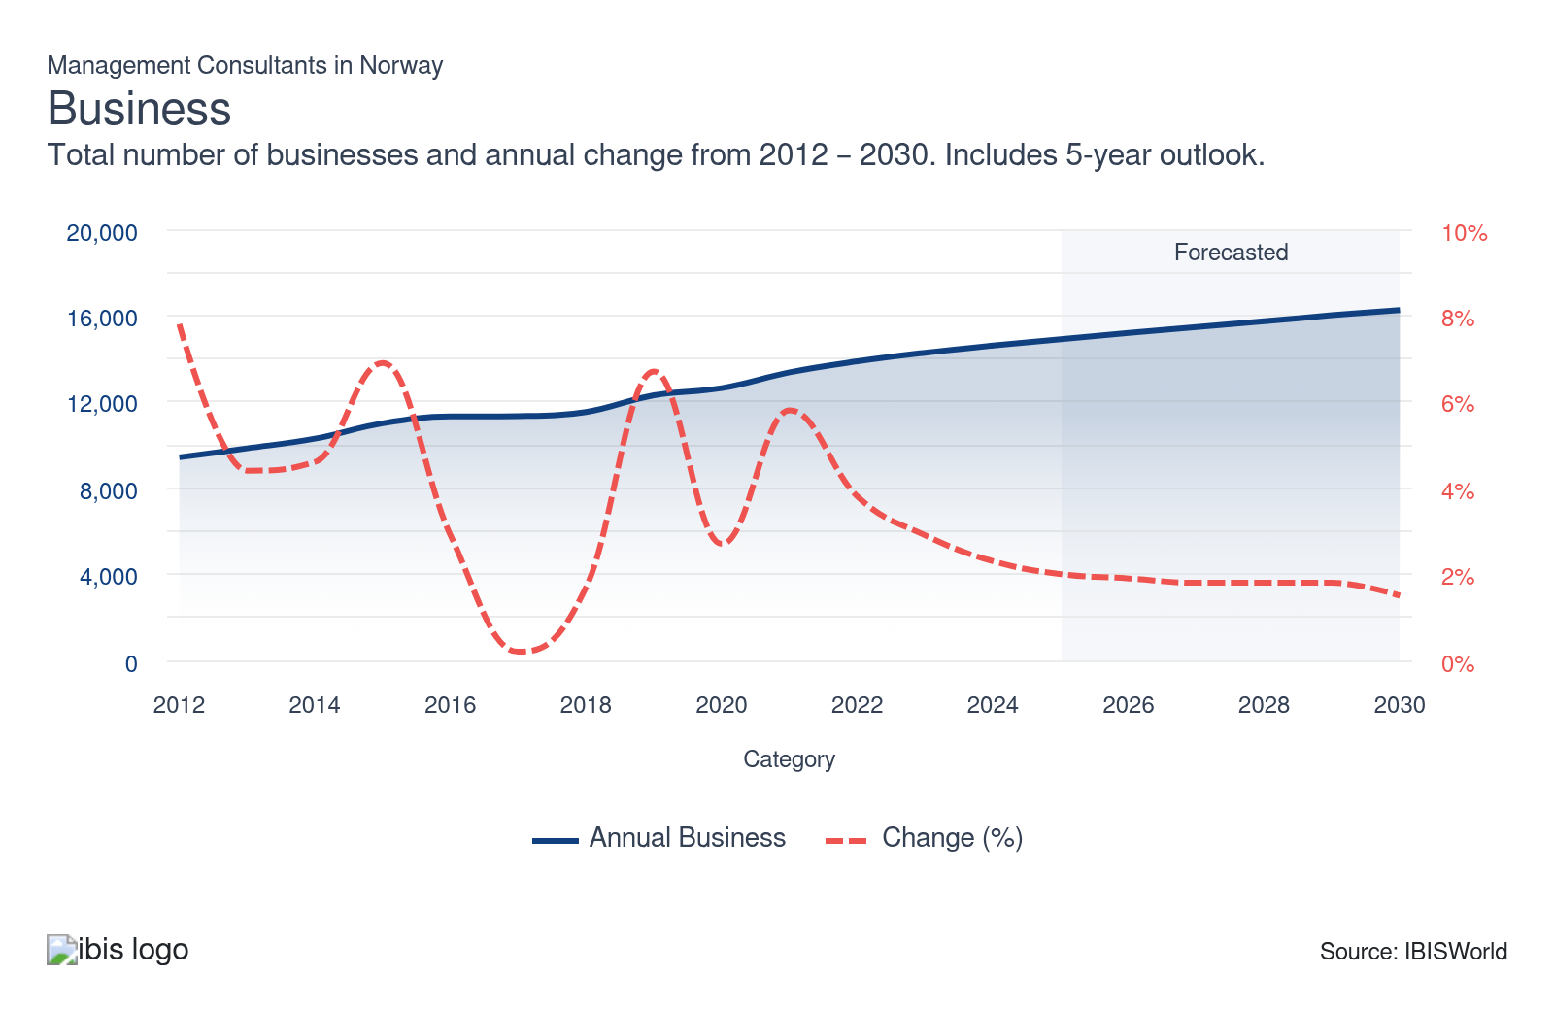

How does Norway's performance compare to Europe?
- In 2025, there are estimated to be 14,901 businesses in the industry in Norway, up 2% compared to the year prior.
- Of the 1.6m industry-related businesses across Europe, Norway accounts for 0.9% of them, making the nation the 21st largest industry across the continent, by number of firms.
- Norway sits 3,028 businesses above the European median of 17,928 firms.
- There are 139 more industry enterprises in Norway compared to Ireland - the nation with the most comparable business demography and home to 14,761 firms.
Total Profit  €857.3m  ’20-’25 ↑ 0.0 % | Profit Margin  24.3%  ’20-’25 ↓ 0.0 pp | Profit per Business  €156.3k
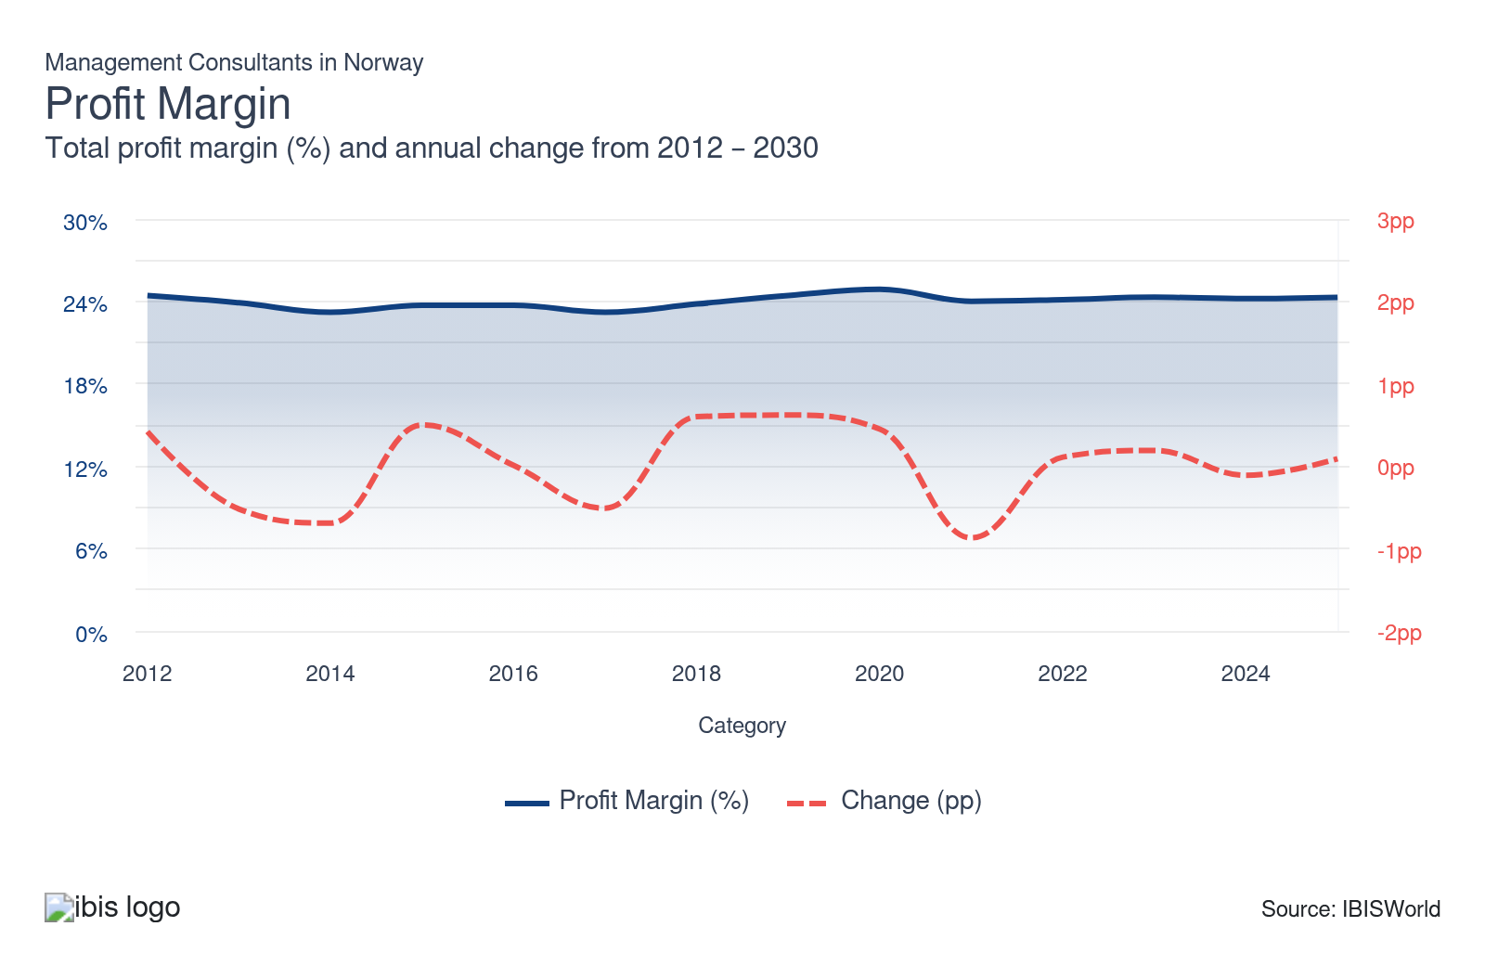

How does Norway's performance compare to Europe?
- The average profit margin in Norway is estimated to rise 0.1 percentage points in 2025, to 24.3%.
- Compared to European counterparts, Norway's operating margin ranks 12th.
- The median profit margin across the continent is 19.6%, meaning Norway is outperforming half of Europe by a gap of 4.7 percentage points.
- There is a 0.0 percentage point difference between Norway and its closest rival in terms of profitability - Latvia in forecast to post an inferior margin of 24.3%.

How do successful businesses overcome volatility?
Develop a strong reputation
Maintaining a positive image and boasting a proven track record is crucial to attract new and larger clients, generate repeat business and achieve consistent revenue growth. A solid reputation is achievable by offering high-quality services and surpassing client expectations.
Develop a loyal customer base
Maintaining a loyal, satisfied customer base ensures repeat business and good word-of-mouth recommendations. This allows consultancy firms to generate steady revenue even during times of uncertainty.

4. Products and Markets
https://my.ibisworld.com/no/en/industry/NO-M702/products-and-markets

Products and Services
- IT strategy
- Corporate strategy
- Process and operations management
- Programme or project management
- Risk management
- Human capital
- Other services

Major Markets
- Financial services sector
- Government departments
- Telecommunications and information sector
- Manufacturing sector
- Energy and utilities sector
- Retail and leisure sector
- Other

What products or services do successful businesses offer?
Be an early adopter of new technologies
Leveraging big data and advanced technology, like AI and machine learning, has become a game-changer for expanding management consulting services. Incorporating these innovative tools drives efficiency and productivity in providing strategic advice and tailored solutions.
Provide a related range of goods and/or services
The broad array of consulting services allows management consultancy firms in Europe to expand their offerings and target various markets, mitigating the effects of economic uncertainty. IT consulting and environmental consulting are two service areas recording strong growth.

5. Competitive Forces
https://my.ibisworld.com/no/en/industry/NO-M702/competitive-forces

Highlights

What is the competitive landscape in Norway?
- The regulatory environment that governs activity in the Management Consultants industry in Norway is lightly competitive.
- One of the most prominent competitive threats to industry operators is supplier power, which are at a Low level in Norway - this is also the case in 16 other countries across Europe, including Lithuania, and Iceland.
- The direct impact on product or service cost and quality because of higher bargaining power held by suppliers - this can drive up prices, result in supply being cut off or otherwise - may force a business to pass on costs to buyers or reduce their margins, thereby weakening their market position.
- Relative to the identified threat, operators in Norway have more scope to gain a competitive advantage in accordance with Low barriers to entry - 13 other European countries also have Low barriers to entry, including Lithuania, and Iceland.
- The presence of barriers preventing potential businesses from entering the industry, safeguard existing operators from added competition beyond the pre-existing and having to compete with more players for finite revenue..

Buyer & Supplier Power
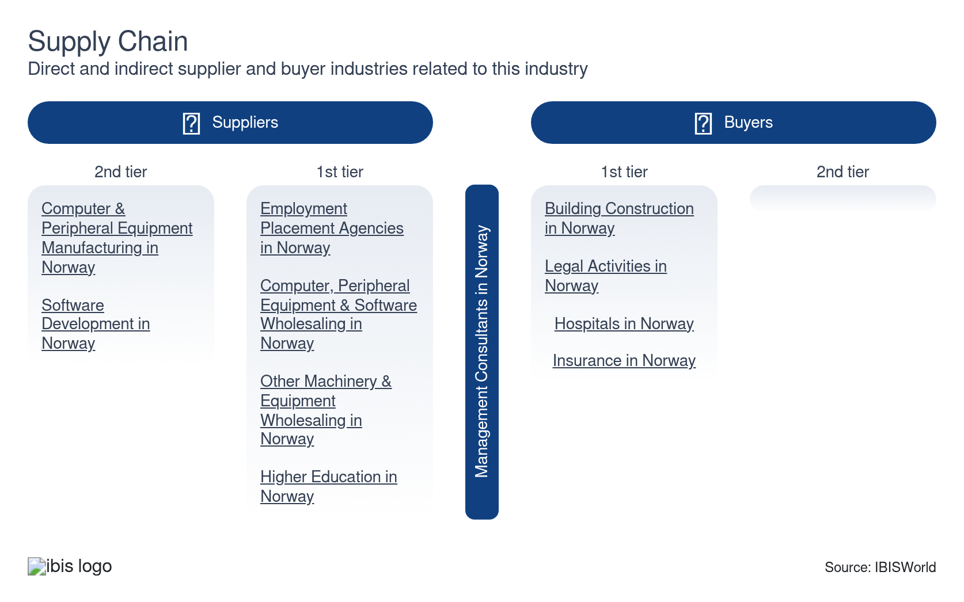

How do successful businesses manage buyer & supplier power?
Possess accurate information
Access to valid and reliable data is crucial as data forms the foundation of a consultant's decision-making process. Inaccurate information can lead to bad advice and ruin client relationships.
Effectively communicate and negotiate
Strong presentation skills, particularly in relation to client report presentations and for tenders, are a key success factor for management consultants.

6. Companies
https://my.ibisworld.com/no/en/industry/NO-M702/companies

No single company accounts for more than 5% of total industry market share.

7. External Environment
https://my.ibisworld.com/no/en/industry/NO-M702/external-environment

Highlights

External Drivers

How does Norway's external environment impact operations?
- The regulatory environment that governs activity in the Management Consultants industry in Norway is strict.
- Operators are subject to regulations and policies which heavily scrutinise business operations, implying business owners in Norway must do more to ensure compliance.
- There are 5 other countries across European where the industry is also subject to a high level of regulation, including Finland and Denmark.
- With regards to external assisstance, operators in Norway receive Moderate support from central government, associated public bodies, trade associations and other non-government entities.
- In addition to generic support options being made available, operators benefit from some which are reserved specifically for those with an interest in the industry.
- Turkey and Denmark, along with 4 other European countries, also have a Moderate level of assistance.

Key External Drivers | Impact
Business sentiment | Positive
Number of enterprises | Positive
Total public expenditure | Positive
Degree of digitalisation | Positive

8. Financial Benchmarks
https://my.ibisworld.com/no/en/industry/NO-M702/financial-benchmarks

Highlights
Profit Margin  24.3 %  ↑ Higher than sector | Average Wage  €63,391 | Largest Cost  Wages

Cost Structure
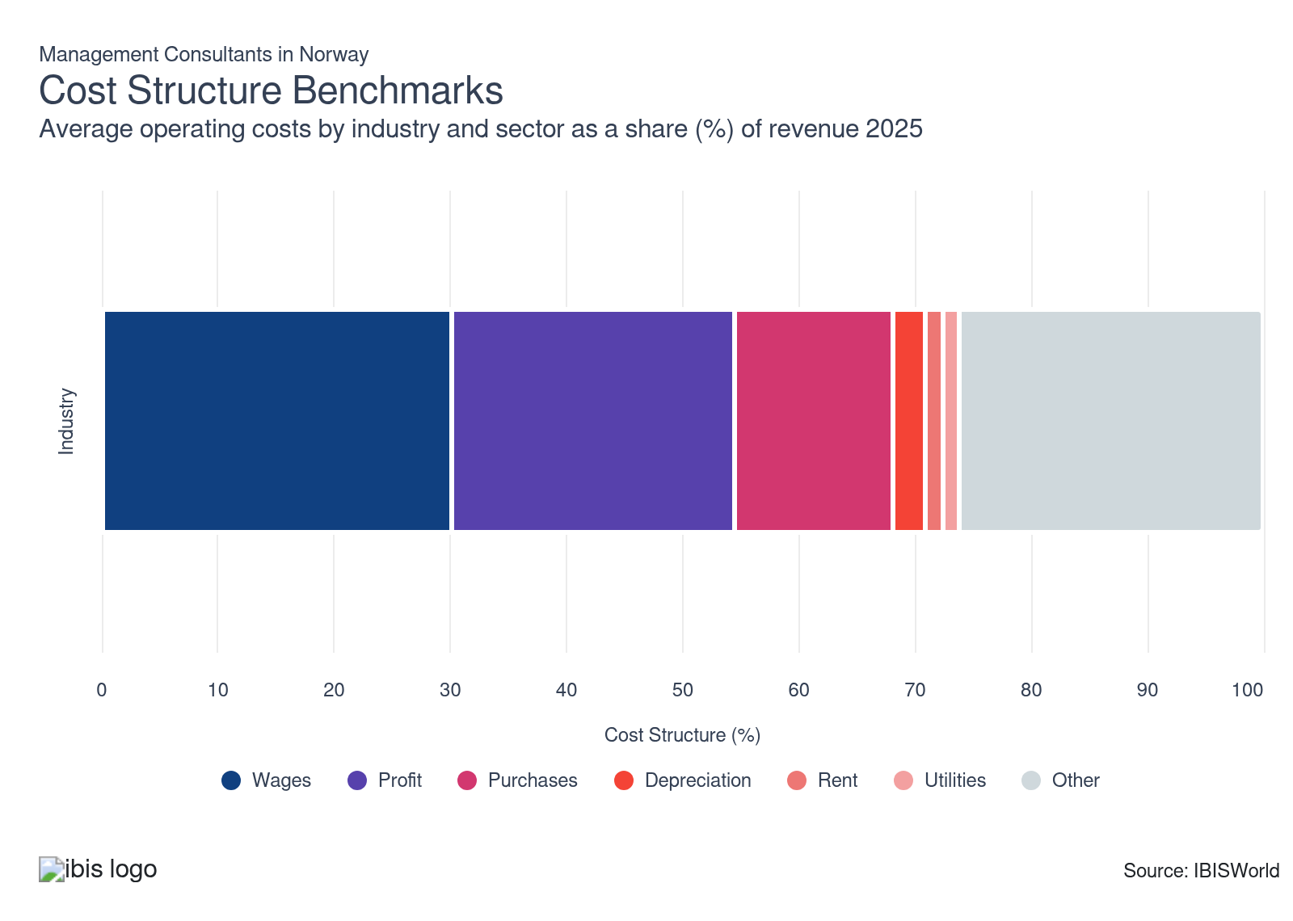
Chart displays current year only in the PDF version of this report. You can view and download chart for all other years associated with this industry on my.ibisworld.com.

How does Norway's cost structure compare to European?
- The Management Consultants in Norway is forecast to have an average operating margin of 24.3% in 2025.
- This ranks 12th in Europe and outperforms the European average of 21.2%, by 3.0 percentage points.
- Absorbing 30.1% of industry revenue, Wages represent the industry's largest classified cost - this is 8.6 percentage points above the continent's average (21.5)% and ranks 0 in Europe.
- The industry in Germany is closested aligned with its counterpart in Norway with regards to profitability, posting a margin 0.2 percentage points above Norway, at 24.5%.
- Conversely, the largest gap in operating profit relative to Norway is Ireland, with the latter underperforming the former by 18.2 percentage points at 6.1%.

Key Ratios
Year | Revenue per Employee  (€) | Revenue per Enterprise  (€ Million) | Employees per Enterprise  (Units) | Average Wage  (€) | Wages/ Revenue  (%) | IVA/ Revenue  (%)
2011 | 348,333 | 0.4 | 1.1 | 112,655 | 32.3 | 59.0
2012 | 346,934 | 0.4 | 1.1 | 116,366 | 33.5 | 59.3
2013 | 328,669 | 0.4 | 1.1 | 109,366 | 33.3 | 58.5
2014 | 335,611 | 0.3 | 1.0 | 107,059 | 31.9 | 57.7
2015 | 324,280 | 0.3 | 1.0 | 105,399 | 32.5 | 55.9
2016 | 296,834 | 0.3 | 1.0 | 96,796 | 32.6 | 60.4
2017 | 286,871 | 0.3 | 1.1 | 94,105 | 32.8 | 59.7
2018 | 267,733 | 0.3 | 1.1 | 90,688 | 33.9 | 60.5
2019 | 271,271 | 0.3 | 1.1 | 89,280 | 32.9 | 61.2
2020 | 279,182 | 0.3 | 1.0 | 92,615 | 33.2 | 62.3
2021 | 251,588 | 0.2 | 1.0 | 83,887 | 33.3 | 61.1
2022 | 193,728 | 0.2 | 1.1 | 60,393 | 31.2 | 56.1
2023 | 215,298 | 0.2 | 1.1 | 66,510 | 30.9 | 56.4
2024 | 209,008 | 0.2 | 1.1 | 63,855 | 30.6 | 56.9
2025 | 210,308 | 0.2 | 1.1 | 63,391 | 30.1 | 57.2
2026 | 211,194 | 0.2 | 1.1 | 62,730 | 29.7 | 57.5
2027 | 213,219 | 0.2 | 1.1 | 62,316 | 29.2 | 57.4
2028 | 215,858 | 0.2 | 1.1 | 61,989 | 28.7 | 57.2
2029 | 218,497 | 0.2 | 1.1 | 61,663 | 28.2 | 57.1
2030 | 221,185 | 0.2 | 1.1 | 61,339 | 27.7 | 56.9
2031 | 223,914 | 0.2 | 1.1 | 61,017 | 27.3 | 56.8
*Figures are inflation adjusted to 2025
*Figures are inflation adjusted to 2025

9. Country Benchmarks
https://my.ibisworld.com/no/en/industry/NO-M702/country-benchmarks

Structural Comparison
Characteristic | United Kingdom Level | Norway Level
Concentration | Moderate | Moderate
Barriers To Entry | Very Low | Low
Regulation and Policy | Low | High
Life Cycle | Mature | Mature
Revenue Volatility | Low | Low
Assistance | High | Moderate
Competition | High | Moderate
Innovation | High | High
Structural Comparison
Structural Comparison
Characteristic | Ireland Level | Norway Level
Concentration | Moderate | Moderate
Barriers To Entry | Very Low | Low
Regulation and Policy | Moderate | High
Life Cycle | Mature | Mature
Revenue Volatility | Low | Low
Assistance | Low | Moderate
Competition | Moderate | Moderate
Innovation | High | High
Structural Comparison
Structural Comparison
Characteristic | France Level | Norway Level
Concentration | Moderate | Moderate
Barriers To Entry | Low | Low
Regulation and Policy | Low | High
Life Cycle | Mature | Mature
Revenue Volatility | Moderate | Low
Assistance | Low | Moderate
Competition | Moderate | Moderate
Innovation | High | High
Structural Comparison
Structural Comparison
Characteristic | Netherlands Level | Norway Level
Concentration | Moderate | Moderate
Barriers To Entry | Low | Low
Regulation and Policy | Moderate | High
Life Cycle | Mature | Mature
Revenue Volatility | Low | Low
Assistance | High | Moderate
Competition | High | Moderate
Innovation | Very High | High
Structural Comparison
Structural Comparison
Characteristic | Belgium Level | Norway Level
Concentration | Moderate | Moderate
Barriers To Entry | High | Low
Regulation and Policy | Low | High
Life Cycle | Mature | Mature
Revenue Volatility | Low | Low
Assistance | High | Moderate
Competition | Moderate | Moderate
Innovation | Very High | High

10. Key Statistics
https://my.ibisworld.com/no/en/industry/NO-M702/key-statistics

Industry Data

Values
Year | Revenue  (€ Million) | IVA  (€ Million) | Enterprises  (Units) | Employment  (Units) | Wages  (€ Million)
2011 | 3,320.0 | 1,959.6 | 8,739 | 9,531 | 1,073.7
2012 | 3,461.7 | 2,053.3 | 9,420 | 9,978 | 1,161.1
2013 | 3,537.0 | 2,068.4 | 9,836 | 10,762 | 1,177.0
2014 | 3,568.4 | 2,057.7 | 10,286 | 10,633 | 1,138.3
2015 | 3,440.7 | 1,923.5 | 10,997 | 10,610 | 1,118.3
2016 | 3,515.7 | 2,122.3 | 11,313 | 11,844 | 1,146.4
2017 | 3,660.8 | 2,184.5 | 11,330 | 12,761 | 1,200.9
2018 | 3,536.2 | 2,137.8 | 11,524 | 13,208 | 1,197.8
2019 | 3,577.8 | 2,188.3 | 12,300 | 13,189 | 1,177.5
2020 | 3,368.8 | 2,099.8 | 12,631 | 12,067 | 1,117.6
2021 | 3,280.2 | 2,003.3 | 13,360 | 13,038 | 1,093.7
2022 | 3,065.2 | 1,718.9 | 13,871 | 15,822 | 955.5
2023 | 3,502.3 | 1,975.2 | 14,271 | 16,267 | 1,081.9
2024 | 3,453.6 | 1,964.4 | 14,606 | 16,524 | 1,055.1
2025 | 3,530.0 | 2,020.1 | 14,901 | 16,785 | 1,064.0
2026 | 3,600.8 | 2,070.8 | 15,191 | 17,050 | 1,069.5
2027 | 3,675.2 | 2,108.6 | 15,459 | 17,237 | 1,074.1
2028 | 3,750.1 | 2,145.7 | 15,731 | 17,373 | 1,076.9
2029 | 3,825.9 | 2,183.3 | 16,009 | 17,510 | 1,079.7
2030 | 3,903.5 | 2,221.7 | 16,253 | 17,648 | 1,082.5
2031 | 3,982.9 | 2,260.7 | 16,479 | 17,787 | 1,085.3

*Figures are inflation adjusted to 2025

Annual Change
Year | Revenue  % | IVA  % | Enterprises  % | Employment  % | Wages  %
2011 | N/A | N/A | N/A | N/A | N/A
2012 | 4.3 | 4.8 | 7.8 | 4.7 | 8.1
2013 | 2.2 | 0.7 | 4.4 | 7.9 | 1.4
2014 | 0.9 | -0.5 | 4.6 | -1.2 | -3.3
2015 | -3.6 | -6.5 | 6.9 | -0.2 | -1.8
2016 | 2.2 | 10.3 | 2.9 | 11.6 | 2.5
2017 | 4.1 | 2.9 | 0.2 | 7.7 | 4.7
2018 | -3.4 | -2.1 | 1.7 | 3.5 | -0.3
2019 | 1.2 | 2.4 | 6.7 | -0.1 | -1.7
2020 | -5.8 | -4.0 | 2.7 | -8.5 | -5.1
2021 | -2.6 | -4.6 | 5.8 | 8.0 | -2.1
2022 | -6.6 | -14.2 | 3.8 | 21.4 | -12.6
2023 | 14.3 | 14.9 | 2.9 | 2.8 | 13.2
2024 | -1.4 | -0.5 | 2.3 | 1.6 | -2.5
2025 | 2.2 | 2.8 | 2.0 | 1.6 | 0.8
2026 | 2.0 | 2.5 | 1.9 | 1.6 | 0.5
2027 | 2.1 | 1.8 | 1.8 | 1.1 | 0.4
2028 | 2.0 | 1.8 | 1.8 | 0.8 | 0.3
2029 | 2.0 | 1.8 | 1.8 | 0.8 | 0.3
2030 | 2.0 | 1.8 | 1.5 | 0.8 | 0.3
2031 | 2.0 | 1.8 | 1.4 | 0.8 | 0.3

*Figures are inflation adjusted to 2025

DISCLAIMER
This product has been supplied by IBISWorld Inc. (‘IBISWorld’) solely for use by its authorized licenses strictly in accordance with their license agreements with IBISWorld. IBISWorld makes no representation to any other person with regard to the completeness or accuracy of the data or information contained herein, and it accepts no responsibility and disclaims all liability (save for liability which cannot be lawfully disclaimed) for loss or damage whatsoever suffered or incurred by any other person resulting from the use of, or reliance upon, the data or information contained herein. Copyright in this publication is owned by IBISWorld Inc. The publication is sold on the basis that the purchaser agrees not to copy the material contained within it for other than the purchasers own purposes. In the event that the purchaser uses or quotes from the material in this publication – in papers, reports, or opinions prepared for any other person – it is agreed that it will be sourced to: IBISWorld Inc.

